**Shraddha Saini**

**R171217055**

**500062194**

**DevOps IV**

**Discuss about thread usage in Remote Method Invocations.**

**(Use a architecure diagram for help)**

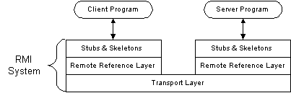

From the Architeture a method dispatched by the Remote Method Invocation, runtime to a remote object implementation (a server) may or may not execute in a separate thread. Calls originating from different clients Virtual Machines will execute in different threads. From the same client machine it is not guaranteed that each method will run in a separate thread”   
Therefore, if you make remote calls from separate clients (executing in different JVMs) each call will run in a separate thread. However, if you make concurrent calls from the same client (this can be acheived by using client-side threading, see later) then it is possible these calls will execute on the same server thread.

**Using Eclipse write a program for File I/O (Create, delete and check availability of file). Also show the output.**

import java.io.File;

import java.io.IOException;

public class Assignment

{

public static void main(String[] args)

{

File temp;

try

{

temp = File.createTempFile("myTempFile", ".txt");

boolean exists = temp.exists();

System.out.println("Temp file exists : " + exists);

if(temp.delete())

{

System.out.println("File deleted successfully");

}

else

{

System.out.println("Failed to delete the file");

}

} catch (IOException e)

{

e.printStackTrace();

}

}

}

